## UC-01: Scheduling a Flight:

| **Sr.**  **No** | **Section** | **Content / Explanation** |
| --- | --- | --- |
| 1 | **Designation** | UC-01 |
| 2 | **Name** | **Schedule a Flight** |
| 3 | **Authors** | Daniyal, Ayesha, Mehreen |
| 4 | **Priority** | Important for system’s success: High  Technological Risk: High |
| 5 | **Scope** | This use case deals with how the Flight manager schedules a flight. |
| 6 | **Criticality** | High |
| 7 | **Stakeholders and interests** | * Flight Manager: Responsible for the entire scheduling of a flight. He wants correct retrieval of data to avoid any hazard. * Pilot: Responsible for piloting the flight. I Want to get all the necessary info about the flight to correctly pilot it. * Flight crew: Responsible for managing Passengers. * Technical crew: Responsible for maintaining the airplane of the flight. * Navigation system: Responsible for identifying the route of the Airplane. * Company: Wants to give their Passengers a tension free and satisfactory ride, and wants to record all the data for future use. * Passenger: Wants to travel faster and with minimum headaches. |
| 8 | **Description** | From the FRS main Screen panel, the Flight manager opens the Flight scheduling panel. The FRS displays a list of routes and date of flight. The Flight manager selects a route and date. The FRS then displays the list of available airplanes that meets the route and date criteria. The flight manager then confirms the Flight by entering the increase or decrease in the ticket price. |
| 9 | **Trigger Event** | The flight manager wishes to schedule a Flight. |
| 10 | **Actors** | Flight Manager, FRS |
| 11 | **Pre-Conditions** | 1. The airplane must be available for scheduling. 2. There must be route available for the city of departure and arrival. 3. The Flight Manager must be logged in. |
| 12 | **Post-Conditions** | 1. Flight is scheduled. 2. Flight records are updated. 3. The fare is generated. 4. Flight is available for booking 5. Airplane Records are updated |
| 13 | **Result** | Flight scheduled |
| 14 | **Main Scenario** | |  |  | | --- | --- | | Flight Manager | Flight Scheduling system | | 1. The Flight Manager opens the Flight scheduling Panel.      1. The flight manager enters the desired departure, arrival and Date and time of the flight.     3. The flight manager may increase or decrease the price. | 1a. The FRS displays the Flight Scheduling options.  1b. The FRS asks the flight manager for city of departure and arrival, Date and time of the flight.  2a. The FRS then displays the Ticket prices (economy, business) and asks for an increase or decrease in price.  3a. The FRS schedules the flight for available airplane.  4b. The FRS displays the details (Fare, capacity, Route, Flight ID) of the Flight. | |
| 15 | **Alternative Scenario** | 1. In case of FRS failure before Flight manager saves the data:    * 1. Flight manager logs in again      2. The FRS will not have any information saved. The Flight manager will have to enter the details again. 2. In case of unavailability of Airplanes:    1. 1. The Flight manager will have to enter alternative timings for flight departure.   If there is no route between the departure city and arrival city, the Flight manager will have to add a route first before scheduling. Else, the FRS will automatically add a route. |
| 16 | **Exception Scenario** | 1. The FRS is unable to log in. 2. The FRS is unable to Airplane Data. 3. The FRS is unable to Route Details. 4. The FRS is unable to fetch airport details. |

**System Sequence Diagram: Scheduling a Flight**  
  
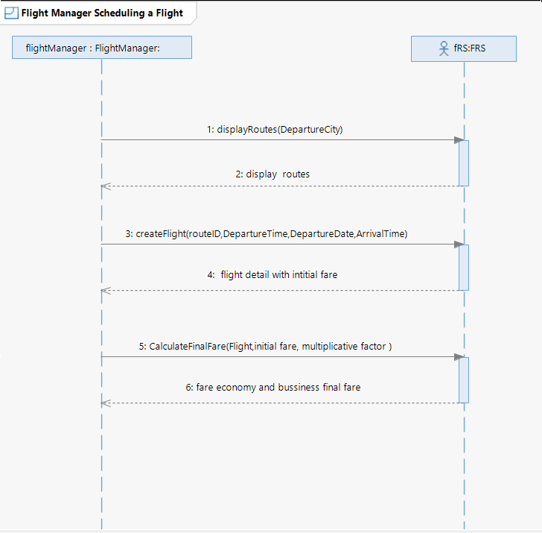

* + 1. **Display Routes:**

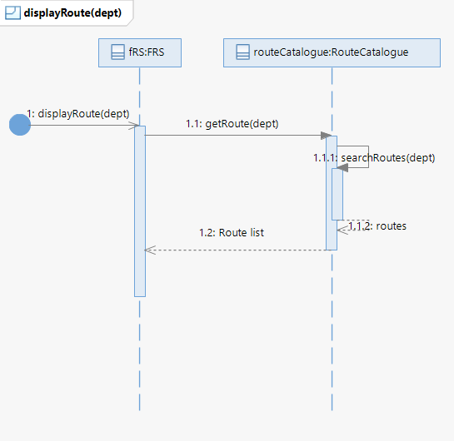

* + 1. **Create Flight:**

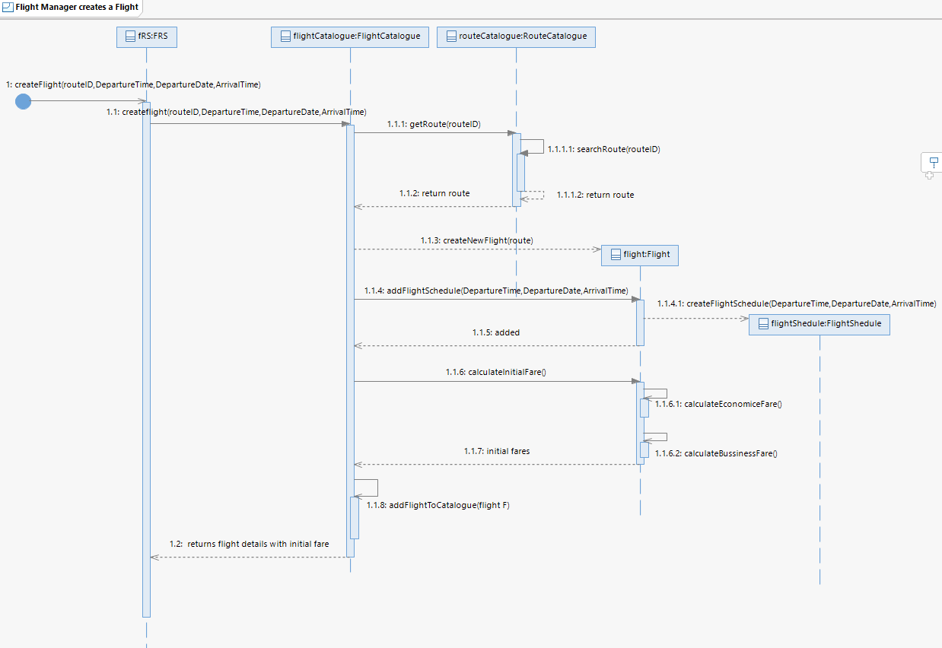

* + 1. **Calculate Final Fares:**

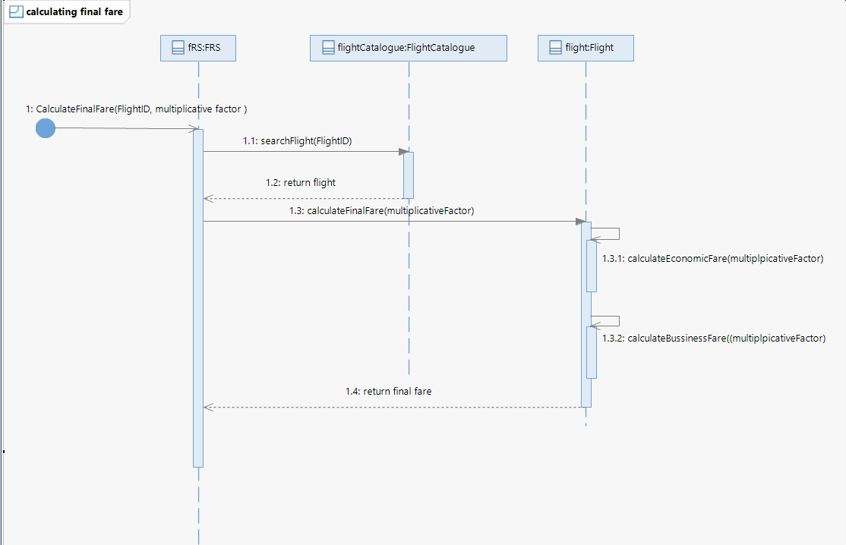

## UC-02: Removing a flight:

|  |  |  |
| --- | --- | --- |
| Sr. | **Section** | Content / Explanation |
| 1 | **Designation** | UC-02 |
| 2 | **Name** | **Remove a Flight** |
| 3 | **Authors** | Daniyal, Ayesha, Mehreen |
| 4 | **Priority** | Important for system’s success: **High** Technological Risk: **High** |
| 5 | **Scope** | This use case deals with how the Flight Manager removes a flight from the schedule. |
| 6 | **Criticality** | High |
| 7 | **Description** | The Flight Manager removes a flight from the schedule by entering its flight ID in the Flight removing Panel of the FRS. |
| 8 | **Trigger Event** | The Flight Manager wants to remove a flight from the schedule. |
| 9 | **Actors** | Flight Manager, FRS |
| 10 | **Pre-Conditions** | 1.        Flight has been scheduled.  2.         Flight Manager is logged in. |
| 11 | **Post-Conditions** | 1.        Flight is removed from the schedule. 2.        Airplane is free to be scheduled for another flight. 3.        Flight records are updated 4. Airplane Records are updated |
| 12 | **Result** | Flight is removed from the schedule. |
| 13 | **Main Scenario** | |  |  | | --- | --- | | Flight Manager Action | System Responsibility | | The Flight Manager opens the Flight management Panel and Selects ‘Flight Removing’. |  | |  | The FRS displays management panel. | |  | FRS displays the Flight Removing Panel. | | The Flight manager enters the flight ID of the flight he wants to remove in the Flight removing Panel of the FRS |  | |  | The FRS displays the details (arrival place, date, time and estimated fare) of the scheduled flight. | | The Flight manager clicks on the Remove Flight link. |  | |  | The FRS prompts “Do you want to remove the flight?” | | The Flight Manager clicks on the Remove button. |  | |  | The FRS displays a message that flight (with flight number) has been removed from the schedule. | |
| 14 | **Alternative Scenario** | In case of system failure:  To support recovery and correct scheduling, the system shall have saved the sensitive information.  1. Flight manager logs in again  2. The system resumes from the prior state. |
| 15 | **Exception Scenario** | 1. The FRS is unable to log in. 2. The FRS is unable to Airplane Data. 3. The FRS is unable to Route Details. 4. The FRS is unable to fetch airport details. 5. The FRS is unable to save the updates i.e., the flight removal 6. Flight ID is invalid. |

**Removing a Flight: System Sequence Diagram**

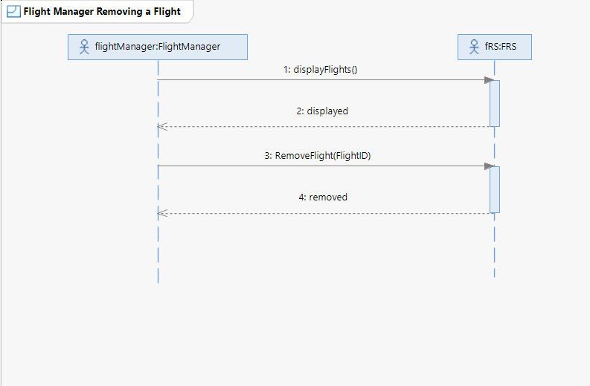

**Sequence Diagrams: Removing a Flight**

1. Display Flights:

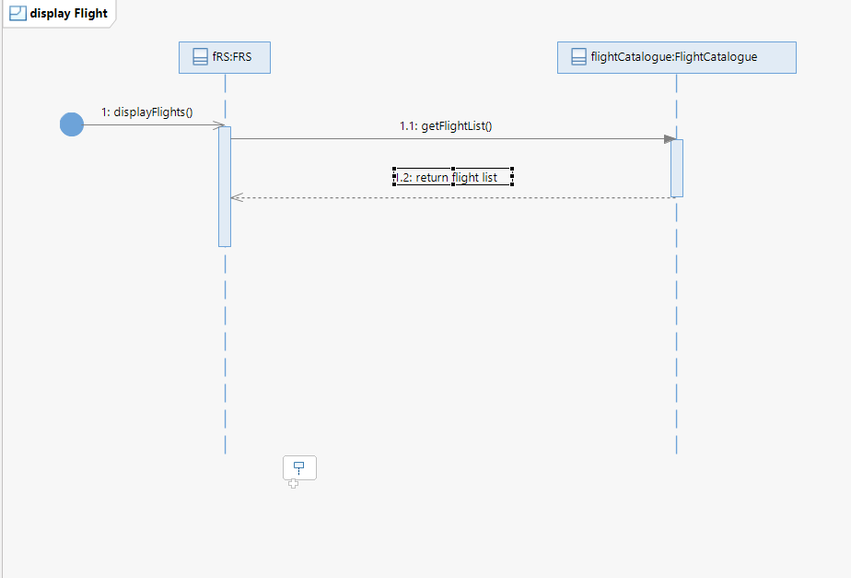

2. Removing A Flight

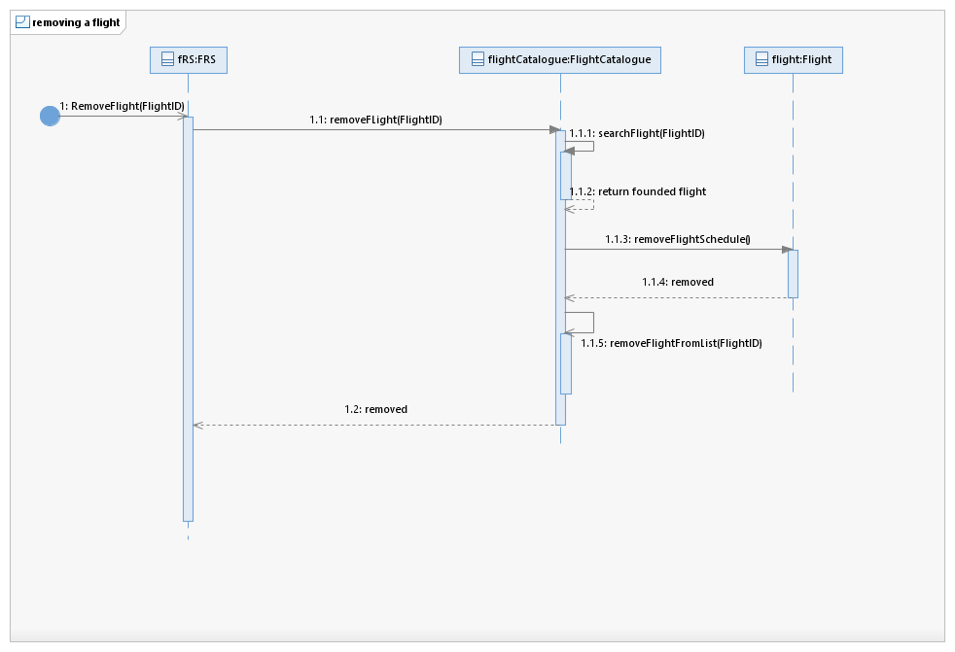

## UC-03: Track Current Flight’s Status:

|  |  |  |
| --- | --- | --- |
| Sr.  No | **Section** | Content / Explanation |
| 1 | **Designation** | UC-03 |
| 2 | **Name** | **Track Flight Status** |
| 3 | **Authors** | Daniyal, Ayesha, Mehreen |
| 4 | **Priority** | Important for system’s success: **High**  Technological Risk: **High** |
| 5 | **Scope** | This use case deals with how the Flight Manager tracks the Status of a flight. |
| 6 | **Criticality** | High |
| 7 | **Description** | The Flight Manager tracks the status of a flight by entering |
| 8 | **Trigger Event** | The Flight Manager wants to track the status of a flight. |
| 9 | **Actors** | Flight Manager |
| 10 | **Pre-Conditions** | Flight has been scheduled.  Flight Manager is logged in. |
| 11 | **Post-Conditions** | Flight Manager can see the status (the current location of airplane), route of the flight |
| 12 | **Result** | Flight Status is displayed. |
| 13 | **Main Scenario** | |  |  | | --- | --- | | Flight Manager Action | System Responsibility | | The Flight manager opens up the manage flights page. |  | |  | The FRS prompts the flight manager to add the flight ID and departure place of the flight he wants to track. | | The Flight manager enters the flight number and the departure place of the flight that he wants to track. |  | |  | The FRS displays the details of the flight such as current location, route, and the time remaining to land the flight. | |  |  | |  |  | |
| 15 | **Exception Scenario** | The FRS is unable to fetch data from the GPS Satellite System.  The FRS is unable to save the updates as the airplane changes its location. |

**System Sequence Diagram: Tracking Flight’s Status**

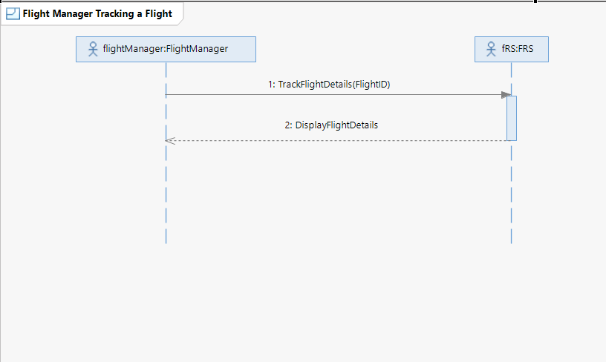

**Sequence Diagrams:**

**1**. **Track Flight Details:  
  
